Honors Chemistry – Ms Wilder 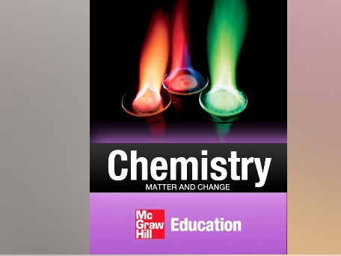
Summer Assignment – 2019

Welcome to Cardinal Spellman’s Honors Chemistry class! I am looking forward to
helping you gain a deep appreciation for the science of chemistry and how it impacts
our lives. I hope you are looking forward to an exciting and challenging year.
I am sure you will learn a great deal next year and you will be challenged. I also
hope you will enjoy learning about the concepts that make our world turn. We are
fortunate to have an i-book for this course and we will use it frequently. In order
to prepare you for a full course in honors chemistry, you are required to complete
the assignments listed below over the summer. You will be using ibook: Chemistry-
Matter and Change published by McGraw Hill. Your first assessment will be on this
material. These assignments are due the first day of class. Please show all your
work, number each question and identify the pages in each chapter on each
assignment. Neatness counts! We will spend a class on these topics before you are
tested on the material in Chapters 1 and 2

Assignments- Chapters 1 and 2 –Required Work
To email me, scan and make it a doc then attach to the email

Chapter 1- Complete by July 31 and email to me
A) Assignment 1 – Read pp 3-27
Pg 45, Questions 25-30
B) Assignment 2 – Read pp 28-37
Pg 46 Questions 37-44
Pg. 49 Q 55,56
C) Study vocab words: chemistry, substance, mass, weight, scientific method,
hypothesis, independent and dependent variable, conclusion, theory, scientific law
(your ibook has the ability to create flash cards for your vocab words. Use this
Resource to study your vocab)

Chapter 2 – Complete by August 21 and email it to me
A) Assignment 1 – Read pp 55-69 . On Pg 118 complete Questions 62, 66-68
B) Assignment2 – Read pp 73-78. On Pg 119 complete Q 71-80
C)Study vocab words: base unit, second, meter, kilogram, kelvin, derived unit, liter,
density, scientific notation, accuracy, precision, error, percent error, significant
figure, dimensional analysis, conversion factor, graph

I will check my email over the summer from time to time. If you have a question
about the assignment, please email me at kwilder@spellman.com
Have a great summer!

